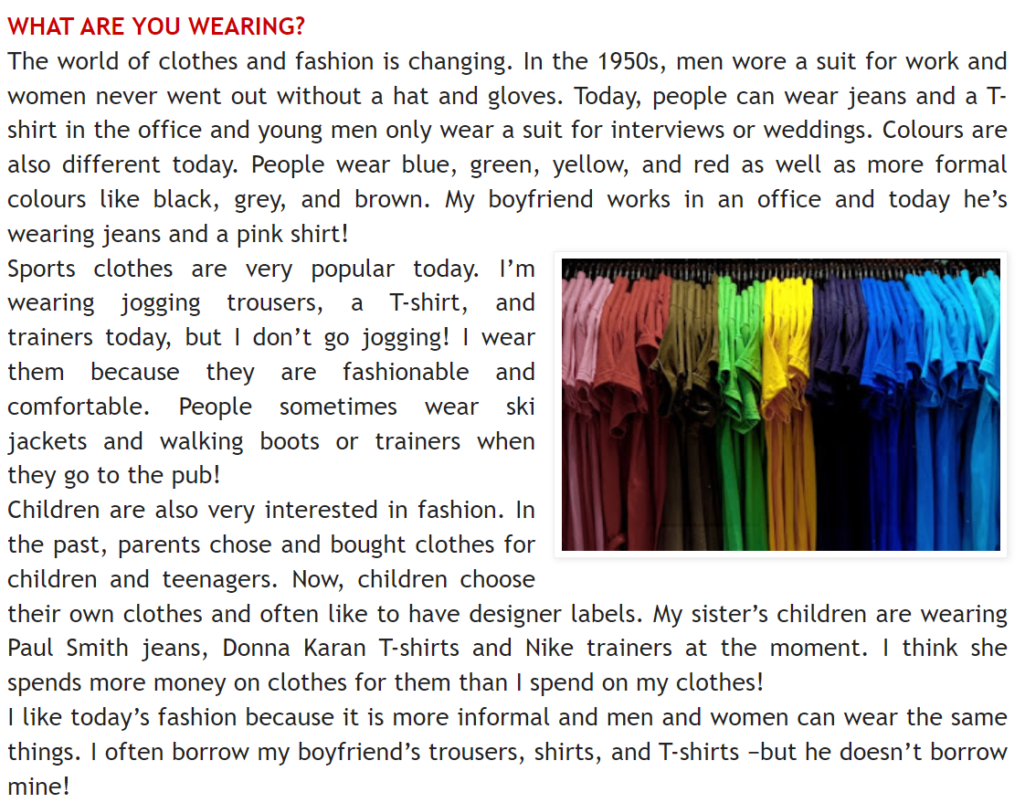New words:

suit – öltöny

wedding – esküvő

formal – hivatalos

jogging – kocogás

trainers – sportcipő

label – címke

borrow – kölcsönvesz

mine – enyém

(Írd le ezeket a szótárfüzetedbe!)

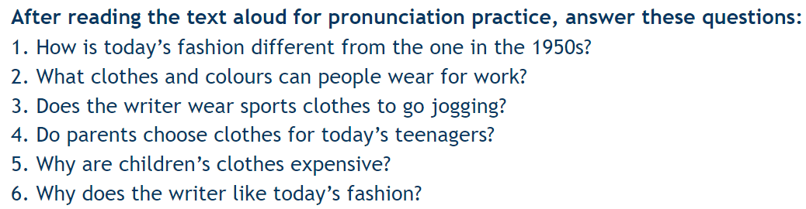

**What clothes are in the text? Write them here**

________________________________________________________________________________________________

__________________ ______________________________________________________________________________

________________________________________________________________________________________________

**Tedd őket ABC-sorrendbe!**

1___________________________ 5______________________________ 9____________________________

2___________________________ 6______________________________ 10____________________________

3___________________________ 7______________________________ 11____________________________

4___________________________ 8______________________________ ____________________________

**Egészítsd ki a mondatokat! Használd a ’used to’ kifejezést!**

I ____________________________ volleyball. (play) My grandma ______________________ walks. (go for)

The children ___________________ in the river. (swim) We ________________ cinema when I was young. (not go)

The old man ______________________ books. (not read) Why ________________________ ice hockey? (you, play)