1. **Choose! /5**

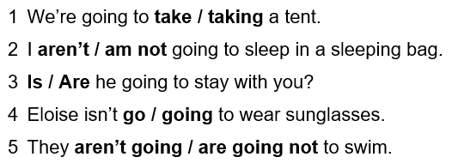

1. **Use the correct form of ’be going to’! /5**

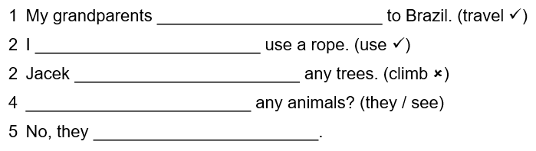

1. **Use ’will’ or ’won’t’. /5**

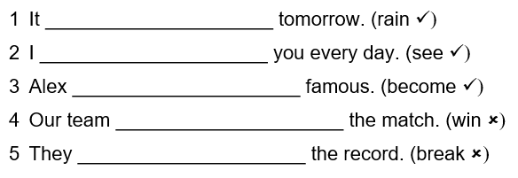

1. **Write the short answer for the questions /5**

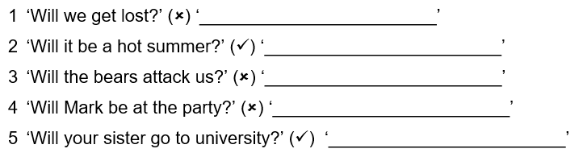

1. **Choose! /5**



1. **Use the correct form of ’be going to’! /5**



1. **Use ’will’ or ’won’t’. /5**



1. **Write the short answer for the questions /5**

