[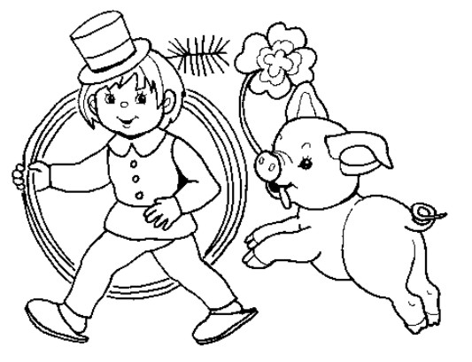](http://www.google.hu/url?sa=i&rct=j&q=&esrc=s&source=images&cd=&cad=rja&uact=8&ved=0ahUKEwjWkfyYlo_KAhUKPxoKHfbzAZkQjRwIBw&url=http%3A%2F%2Fertekkereso.hu%2Fdoc%2Fhittan%2Fkifestok%2Funnep%2Fegyeb_unnep%2F&psig=AFQjCNFFyIumLf_oPkXp6b12jnWJRFiqug&ust=1451963081247120)

[](http://www.google.hu/url?sa=i&rct=j&q=&esrc=s&source=images&cd=&cad=rja&uact=8&ved=0ahUKEwjWkfyYlo_KAhUKPxoKHfbzAZkQjRwIBw&url=http%3A%2F%2Fertekkereso.hu%2Fdoc%2Fhittan%2Fkifestok%2Funnep%2Fegyeb_unnep%2F&psig=AFQjCNFFyIumLf_oPkXp6b12jnWJRFiqug&ust=1451963081247120)

[](http://www.google.hu/url?sa=i&rct=j&q=&esrc=s&source=images&cd=&cad=rja&uact=8&ved=0ahUKEwjWkfyYlo_KAhUKPxoKHfbzAZkQjRwIBw&url=http%3A%2F%2Fertekkereso.hu%2Fdoc%2Fhittan%2Fkifestok%2Funnep%2Fegyeb_unnep%2F&psig=AFQjCNFFyIumLf_oPkXp6b12jnWJRFiqug&ust=1451963081247120)